**AIM:**

**To implement insertion sort in C to sort a list of elements in ascending order.**

**📌 ALGORITHM: *(Insertion Sort)***

1. Start from the second element (index 1) of the array.
2. Compare the current element with the elements before it.
3. Shift all larger elements one position to the right.
4. Insert the current element into its correct position.
5. Repeat until the entire array is sorted.

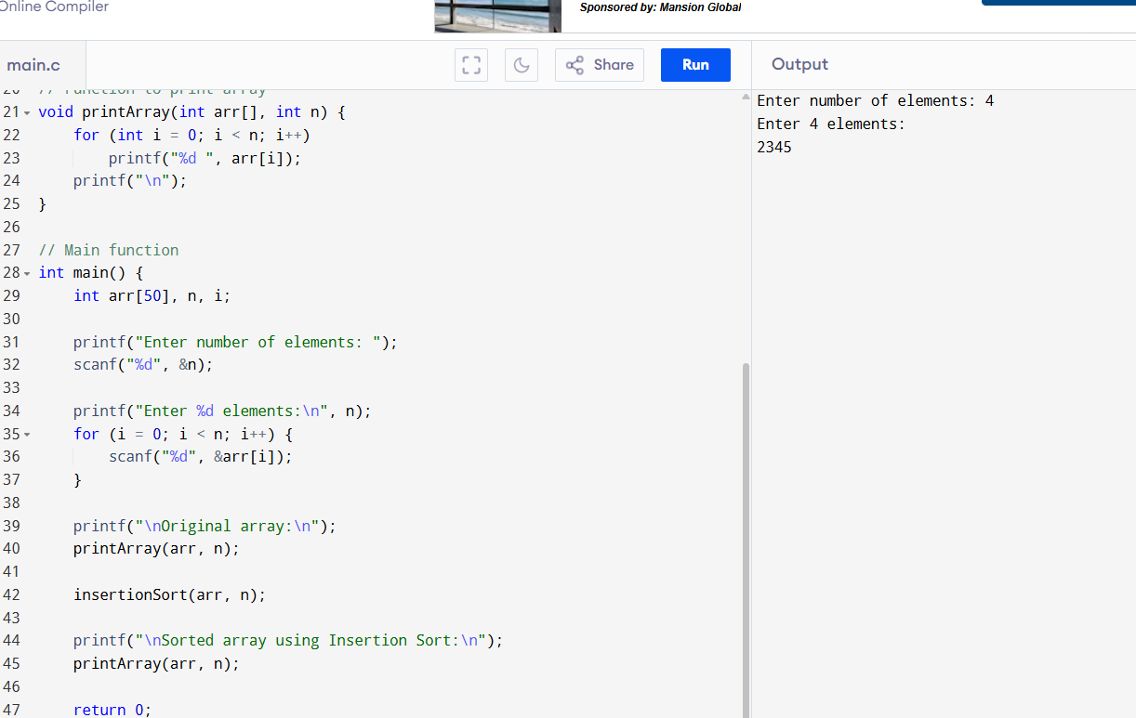

**SAMPLE OUTPUT:**

Enter number of elements: 5

Enter 5 elements:

34 10 64 51 32

Original array:

34 10 64 51 32

Sorted array using Insertion Sort:

10 32 34 51 64